Name: Brett Goerl
Professor: Alexander Cowan
Course: Independent Research (SYQ2)

Tether: Solving the Last Mile Problem in Mental Health Through Intelligent Social Prescribing
Positioning Statement
For healthcare organizations that need to connect patients to community resources, Tether is a social prescribing platform that matches patients to local organizations and activities based on psychometric compatibility, not just ZIP code and eligibility. Unlike Findhelp or Unite Us, Tether considers energy patterns, interaction preferences, sensory needs, and past interests to generate personalized Community Care Plans. Unlike generic 211 directories, Tether explains why each resource fits and gives patients low-barrier next steps. By combining clinician-set guardrails with patient-reported preferences, Tether solves the last-mile problem in mental health: getting patients to actually engage with the community resources that support their recovery.
Defining Success
Success for Tether means validating that psychometric matching is a viable approach to improving social prescribing adherence. As a product concept developed during graduate training, Tether's goal is to demonstrate a defensible solution to a real clinical problem that could be taken to market in the future.
Validation requires three things. First, clinical credibility: the assessment logic, resource taxonomy, and matching algorithm must reflect genuine clinical practice, not theoretical abstractions. Second, user research validity: personas, user stories, and wireframes must be grounded in real pain points observed in community mental health settings. Third, product feasibility: the technical architecture must be buildable with modern tools at reasonable cost, and the business model must show a realistic path to sustainability.
If the final product design demonstrates clinical soundness, user-centered design, and technical feasibility, Tether will be positioned for future development when timing and resources allow.
Tether User Personas

Overview
Tether serves two distinct users: clinicians who set clinical constraints and approve Community Care Plans, and patients who complete psychometric assessments and receive personalized resource recommendations. This document profiles one persona for each user type.

Clinician Persona: Dr. Sarah Chen

Screening Questions
These questions identify clinicians who match our target user profile:
1. How often do your patients follow through on community resource referrals?
2. Walk me through how you currently connect patients to community resources.
3. What happens after you give a patient a resource referral?
4. How much time do you typically spend on resource referrals per patient?

Profile
Dr. Sarah Chen, 38, is a psychiatrist at Valley Community Mental Health Center in Roanoke, VA. She manages a panel of 90 patients, mostly Medicaid and Medicare. She works alongside two psychiatric NPs and shares a part-time social worker with three other providers. Ten years into practice, she's pragmatic about technology. If it doesn't fit her workflow, she won't use it.
Sarah knows that social connection is critical to her patients' recovery. She's seen too many patients stabilize on medication only to relapse because they're isolated. But she doesn't have time to research local resources, and the generic 211 printouts she gives patients end up in the trash. The social worker is overwhelmed with paperwork and can't do proper follow-up. Sarah wants a better way to connect patients to the right resources without adding significant time to her appointments.

Thinks / Sees / Feels / Does
Thinks | Sees
"Social connection matters for outcomes, but I don't have time to research every local resource."  "Generic referrals don't work. The printouts end up in the trash."  "If this adds more than 5 minutes to my workflow, I won't use it." | Patients who stabilize on meds but relapse due to isolation.  A social worker buried in paperwork who can't do proper matching.  Findhelp and 211 in her EHR, but nobody uses them because results feel irrelevant.
Feels | Does
Frustrated that the "soft" stuff is what makes or breaks outcomes but there's no good tool for it.  Skeptical of new software promises.  Protective of her time and her patients' dignity. | Scribbles resource names on paper or prints generic 211 lists.  Asks the social worker to follow up, knowing it's inconsistent.  Moves on to the next patient because there's no better option.

Jobs to be Done
Job | Current Alternative | Tether's Value
Connect patients to community resources that actually fit them | Generic 211 printouts, Findhelp searches, handwritten notes | Personalized Community Care Plans based on psychometric matching, not just ZIP code
Set appropriate guardrails for each patient's acuity level | Mental note-keeping, verbal instructions to social worker | Clinician-controlled resource tiers (clinical, structured, lifestyle) based on treatment phase
Improve patient outcomes without adding workflow burden | Skip the referral entirely because it takes too long | 3-minute input generates a complete Care Plan; patient completes assessment independently

User Story
As Dr. Chen, a psychiatrist at a community mental health center, I want to generate a personalized Community Care Plan for my patient based on their diagnosis, treatment phase, and preferences, so that I can connect them to resources they'll actually use without adding significant time to my appointments.

Patient Persona: Marcus Thompson

Screening Questions
These questions identify patients who match our target user profile:
1. When your provider recommended getting more socially involved, what did you do next?
2. How many community activities or groups have you attended in the past 3 months?
3. Tell me about the last time you tried joining a group or activity.
4. What time of day do you typically have the most energy?

Profile
Marcus Thompson, 34, has moderate depression (MDD) and recently stabilized on sertraline after six months of medication adjustments. He works remotely as a customer service rep and lives alone in an apartment. He moved to Roanoke two years ago for a relationship that ended, and his social network never recovered. Dr. Chen has told him to "get involved in something," but generic lists of resources feel overwhelming and irrelevant.
Marcus isn't hopeless. He takes his medication consistently and shows up to appointments. But his energy is low, especially in the evenings. He used to enjoy hiking and being outdoors, but he doesn't have anyone to go with anymore. The one support group he tried felt depressing and made him feel worse. What he needs is something that fits his energy patterns, doesn't require too much social intensity upfront, and connects to interests he used to have.

Thinks / Sees / Feels / Does
Thinks | Sees
"I know I should get out more, but everything feels like too much effort."  "The last support group I tried was depressing and made me feel worse."  "I used to like hiking, but I don't have anyone to go with." | Generic lists of resources that don't feel like they're for him.  Meetup groups that seem intimidating or too high-energy.  His empty apartment and the same Netflix shows every night.
Feels | Does
Low motivation but not hopeless.  Embarrassed about needing help finding social activities.  Skeptical that an app or list will understand what he actually needs. | Takes his medication consistently.  Works from home, rarely leaves except for groceries.  Tells Dr. Chen "I'll try" but doesn't follow through.

Jobs to be Done
Job |  | Current Alternative | Tether's Value
Find community resources that fit my energy, preferences, and interests |  | Scroll through Meetup or Google, get overwhelmed, give up | Personalized recommendations matched to energy patterns, interaction style, and past interests
Understand why a resource is recommended for me |  | No explanation; generic lists with no context | Match rationale for each recommendation explains why it fits
Take the first step without feeling overwhelmed |  | Tell myself "I'll try" and then don't | Low-barrier next steps (drop-in, morning times, side-by-side activities) reduce activation energy

User Story
As Marcus, a patient with depression who has been told to get more socially involved, I want to receive resource recommendations that match my energy patterns, interaction preferences, and past interests, so that I can find something I'll actually attend instead of another list that ends up ignored.

Example: Marcus's Community Care Plan
Dr. Chen sets Marcus to "early recovery" acuity, approves all three resource tiers, and notes: mornings are better for energy, prefers side-by-side activities over face-to-face conversation, past interest in hiking and outdoors.

Clinical Resource Example
CBT Skills Group at Valley Behavioral Health
• Thursdays 10am, 8 weeks, insurance accepted, small group of 6
• Match rationale: Morning time slot aligns with energy pattern, skills-based format provides structure, small group reduces social overwhelm

Structured Community Resource Example
NAMI Peer-to-Peer Course
• Saturdays 9am, 8-week series, free, facilitated by trained peers
• Match rationale: Psychoeducation format is lower pressure than process group, morning slot, time-limited commitment reduces barrier to entry

Lifestyle Resource Example
Blue Ridge Hiking Club Beginner Group
• Saturdays 8am, meets at trailhead, drop-in, free
• Match rationale: Leverages past interest in hiking, side-by-side activity minimizes conversation pressure, outdoor setting, morning energy alignment, no ongoing commitment required

Tether User Stories

Clinician Epic: Dr. Sarah Chen

Epic User Story
As Dr. Chen, a psychiatrist at a community mental health center, I want to generate a personalized Community Care Plan for my patient based on their diagnosis and treatment phase, so that I can connect them to resources they'll actually use without adding significant time to my appointments.

Child Stories
# | User Story | Testing Prompts | OEC
1 | As Dr. Chen, I want to select my patient's diagnosis from a list so I can ensure the recommendations are clinically appropriate. | "Select the diagnosis for this patient." Can the subject locate and select a diagnosis? | % who complete selection in <30 sec; % who select correct diagnosis from scenario
2 | As Dr. Chen, I want to set my patient's treatment phase (acute, early recovery, stable) so I can control the intensity of recommended resources. | "This patient just stabilized. Set the appropriate treatment phase." Does subject choose correctly? | % who select appropriate phase; time to selection
3 | As Dr. Chen, I want to select which resource tiers are appropriate (clinical, structured community, lifestyle) so I can match recommendations to my patient's current needs. | "This patient is stable. Which resource types would you allow?" Can subject adjust tiers? | % who can articulate tier differences; % who adjust tiers based on scenario
4 | As Dr. Chen, I want to flag specific environments to avoid so I can protect my patient from harmful situations. | "This patient has AUD. What would you flag?" Does subject find and use the flag feature? | % who locate flag feature; % who apply appropriate flags
5 | As Dr. Chen, I want to review the generated Community Care Plan before sharing it so I can verify the recommendations make sense. | "Review this Care Plan. Would you approve it?" Can subject identify match rationale? | % who review all recommendations; % who catch intentional mismatch
6 | As Dr. Chen, I want to send the assessment link to my patient so they can complete their preferences on their own time. | "Send this to your patient." Can subject complete the send flow? | % who complete send flow; time from review to send

Patient Epic: Marcus Thompson

Epic User Story
As Marcus, a patient with depression who has been told to get more socially involved, I want to receive resource recommendations that match my energy patterns, interaction preferences, and past interests, so that I can find something I'll actually attend instead of another list that ends up ignored.

Child Stories
# | User Story | Testing Prompts | OEC
1 | As Marcus, I want to answer questions about my schedule availability so I can receive recommendations that fit my routine. | "When are you typically free?" Complete the schedule section. Was it clear? | % who complete schedule input; avg time to complete
2 | As Marcus, I want to indicate my preferred group size so I can avoid situations that feel overwhelming. | "What size groups are you comfortable with?" Can subject find and set preference? | % who set group size; % who understand what each option means
3 | As Marcus, I want to share my interaction style preference so I can find resources that match my comfort level. | "Do you prefer activities where you talk face-to-face or do something side-by-side?" Can subject distinguish? | % who select an option; % who can explain their choice
4 | As Marcus, I want to identify interests I used to enjoy so I can reconnect with activities that might still resonate. | "What did you enjoy before you felt this way?" Can subject input past interests? | % who enter at least one interest; avg number of interests entered
5 | As Marcus, I want to see why each resource was recommended for me so I can trust that the suggestions are personalized. | "Why was this recommended to you?" Can subject locate and understand match rationale? | % who find rationale; % who can paraphrase why it fits
6 | As Marcus, I want to view the logistics for each resource so I can decide if it's realistic for me. | "Could you attend this?" Can subject find time, location, cost, and signup info? | % who locate all 4 logistics fields; time to find each
7 | As Marcus, I want to indicate which recommendations I'm interested in so I can get help taking the next step. | "Mark the ones you'd consider attending." Can subject express interest? | % who mark at least one; % who understand what happens next
8 | As Marcus, I want to dismiss recommendations that don't feel right and explain why so I can improve future suggestions. | "This one doesn't fit. Tell Tether why." Can subject dismiss and provide reason? | % who find dismiss function; % who provide a reason

Handoff: Clinician to Patient
This story bridges the clinician and patient workflows, covering the moment when the patient receives and opens their assessment link.
# | User Story | Testing Prompts | OEC
H1 | As Marcus, I want to understand what Tether is and why my doctor sent it to me so I can decide whether to complete the assessment. | "You just got this link from your doctor. What is this? Would you continue?" Does subject understand purpose? | % who can explain purpose; % who proceed past intro screen

Storyboard Example: Marcus's Journey
1. Trigger
Marcus leaves his appointment with Dr. Chen. She mentioned he should "get more involved" but he's heard that before. This time, she says she's sending him something different.
2. Receiving the Link
That evening, Marcus gets a text with a link to Tether. The message explains it will help find activities that fit him specifically. He's skeptical but clicks through.
3. Completing the Assessment
Marcus answers questions about his schedule, energy patterns, and preferences. He notes that mornings are better, he prefers doing activities alongside others rather than face-to-face conversation, and he used to enjoy hiking. It takes about 5 minutes.
4. Viewing Recommendations
Tether generates his Community Care Plan with three recommendations. Each one shows why it was matched to him. The hiking club catches his eye because it says "side-by-side activity, morning time slot, leverages past interest."
5. Taking Action
Marcus marks interest in the hiking club. Tether shows him the next step: the group meets Saturday at 8am at a specific trailhead, drop-in, no registration required. He adds it to his calendar.
6. Resolution
Saturday morning, Marcus shows up. The group is small, the pace is easy, and nobody pressures him to talk much. On the drive home, he thinks: that wasn't bad. He might go again next week.

Wireframes

Clinician Flow
The clinician flow enables providers like Dr. Sarah Chen to create personalized Community Care Plans for patients during or after appointments. The flow captures diagnosis, treatment phase, and resource constraints to ensure recommendations are clinically appropriate.

Screen C1: Patient Selection
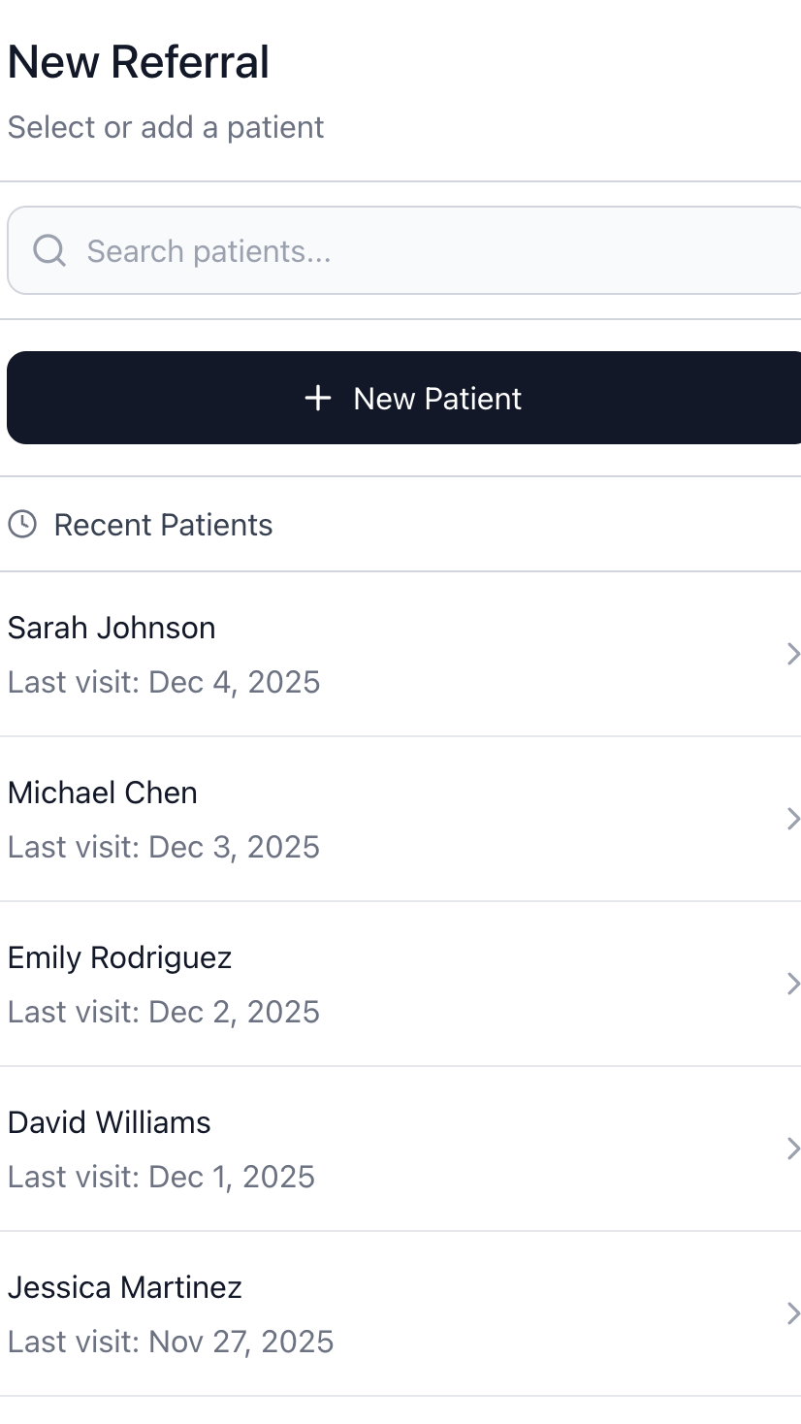
New Referral: Select or add a patient
User Story Addressed:
As Dr. Chen, I want to quickly find or add a patient so I can start building their Community Care Plan without disrupting my appointment flow.
Key UI Elements:
Search bar for existing patients, New Patient button for intake, Recent Patients list sorted by last visit date with clear row affordance

Screen C2: Diagnosis Selection
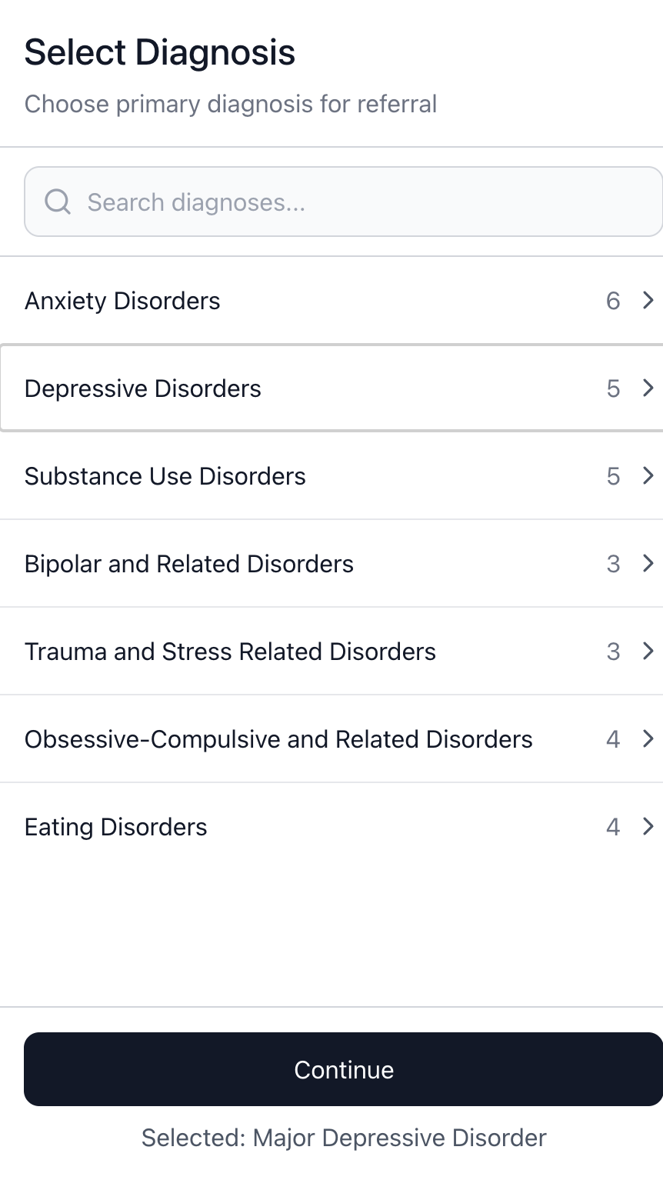
Select Diagnosis: Choose primary diagnosis for referral
User Story Addressed:
As Dr. Chen, I want to select my patient's diagnosis from a list so I can ensure the recommendations are clinically appropriate. (Child Story #1)
Key UI Elements:
Search bar for quick lookup, diagnosis categories with counts showing available sub-diagnoses, expandable rows (arrow affordance), footer confirmation showing current selection
Design Decision:
Categories group related diagnoses to reduce cognitive load. The count badge (e.g., "6") signals drill-down availability. Selected diagnosis persists in footer for confirmation before advancing.

Screen C3: Treatment Parameters
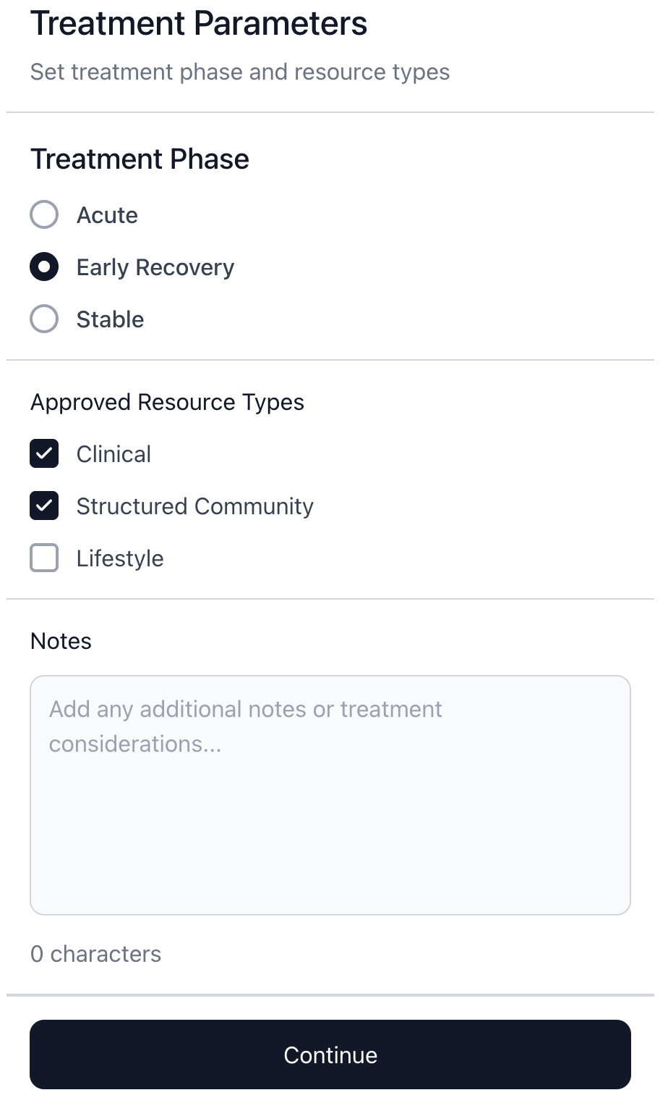
Treatment Parameters: Set treatment phase and resource types
User Stories Addressed:
As Dr. Chen, I want to set my patient's treatment phase (acute, early recovery, stable) so I can control the intensity of recommended resources. (Child Story #2)
As Dr. Chen, I want to select which resource tiers are appropriate (clinical, structured community, lifestyle) so I can match recommendations to my patient's current needs. (Child Story #3)
Key UI Elements:
Radio buttons for mutually exclusive treatment phase, checkboxes for resource tiers (can approve multiple), Notes field for freeform clinical context
Design Decision:
Treatment phase uses radio buttons because only one phase applies at a time. Resource types use checkboxes because clinicians may approve multiple tiers. The Notes field captures edge cases without cluttering the interface.

Screen C4: Community Care Plan Review
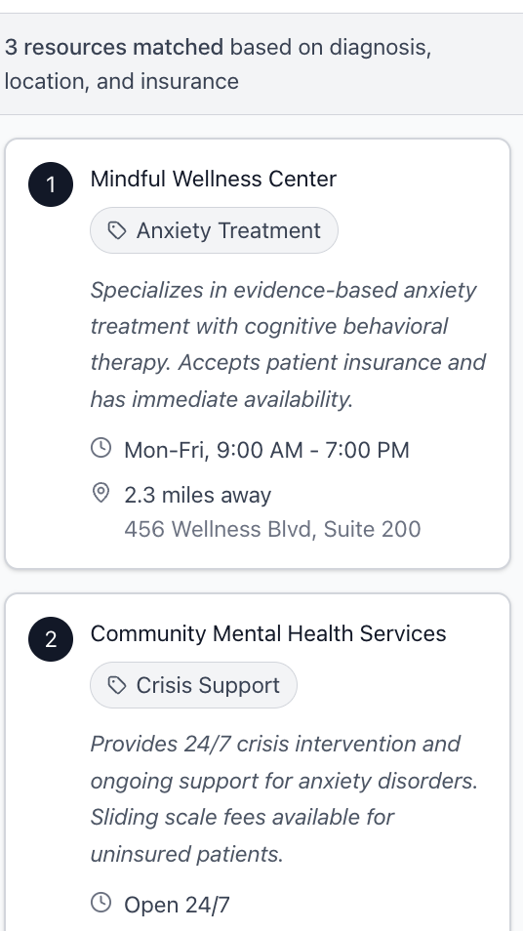
Community Care Plan: Recommended resources for patient
User Story Addressed:
As Dr. Chen, I want to review the generated Community Care Plan before sharing it so I can verify the recommendations make sense. (Child Story #5)
Key UI Elements:
Ranked resource cards with priority numbers, resource type tags (Anxiety Treatment, Crisis Support), description and logistics (hours, distance, address) visible at a glance, matching rationale summary in header
Design Decision:
Resources are numbered to indicate matching strength. Key logistics (hours, distance) appear on cards so clinicians can quickly assess fit without drilling down. The header confirms matching was based on diagnosis, location, and insurance.

Patient Flow
The patient flow begins when Marcus Thompson receives a link from his provider. The flow captures psychometric preferences through a brief assessment and presents personalized recommendations with clear match rationale.

Screen P1: Welcome
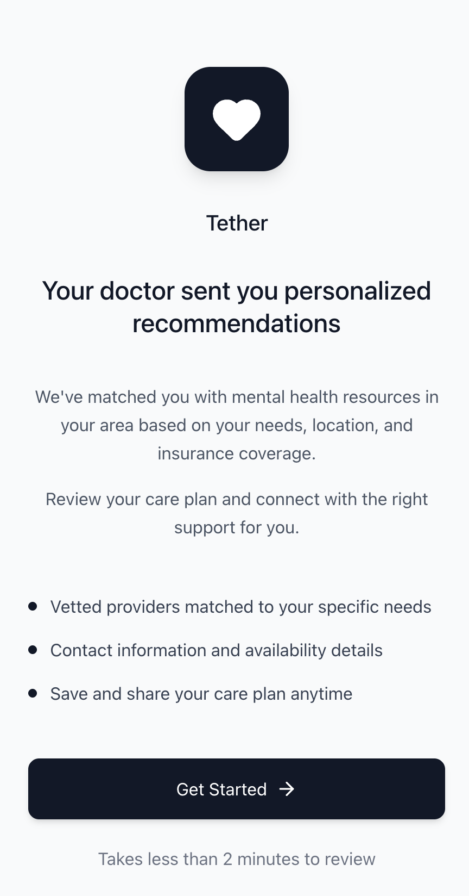
Welcome: Your doctor sent you personalized recommendations
User Story Addressed:
As Marcus, I want to understand what Tether is and why my doctor sent it to me so I can decide whether to complete the assessment. (Handoff Story H1)
Key UI Elements:
Clear branding and value proposition, bullet points explaining what to expect (vetted providers, contact info, save/share), time commitment ("Takes less than 2 minutes"), prominent Get Started CTA
Design Decision:
The screen emphasizes that the doctor initiated this referral (building trust) and that the process is quick (reducing friction). Three bullet points set expectations without overwhelming.

Screen P2: Assessment Question
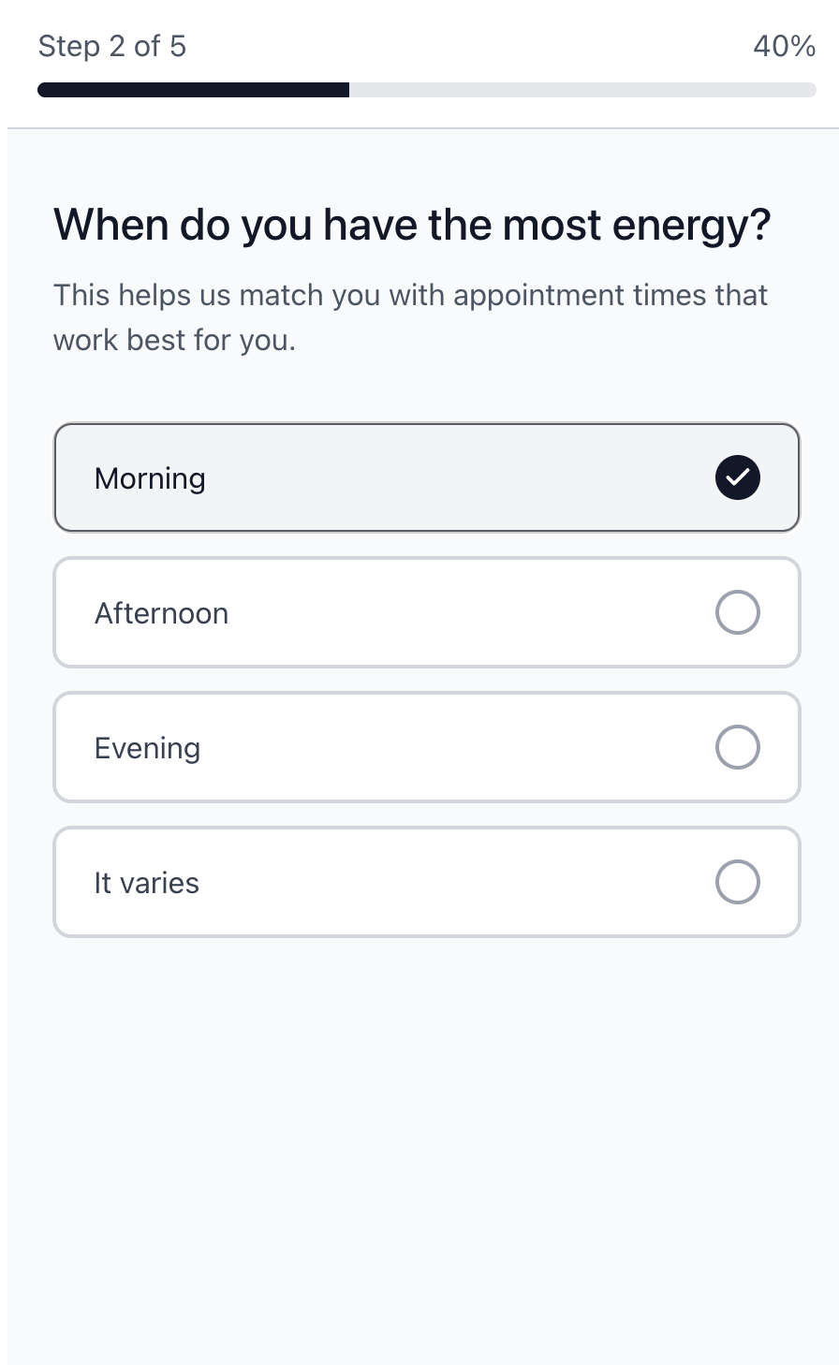
Assessment: When do you have the most energy?
User Stories Addressed:
As Marcus, I want to answer questions about my schedule availability so I can receive recommendations that fit my routine. (Child Story #1)
Energy pattern questions support: As Marcus, I want to find community resources that fit my energy patterns, preferences, and interests. (Epic)
Key UI Elements:
Progress indicator (Step 2 of 5, 40%), clear question with helper text explaining why it matters, single-select radio options, "It varies" option for flexibility
Design Decision:
Helper text ("This helps us match you with appointment times that work best") explains how the question improves recommendations. Progress bar reduces abandonment by showing completion is near.

Screen P3: Community Care Plan Results
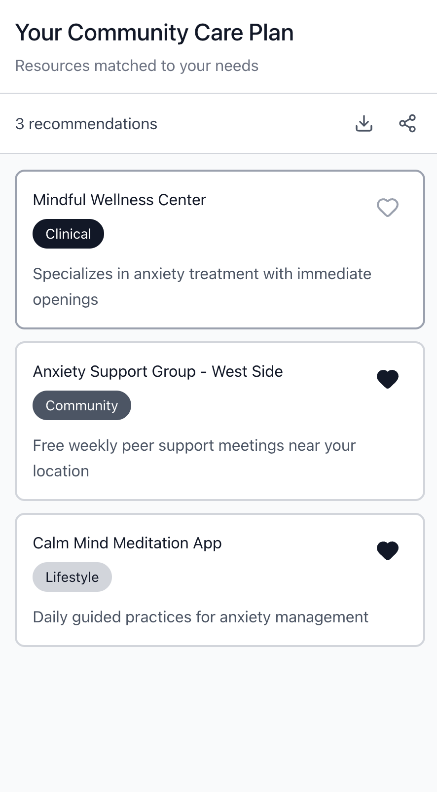
Your Community Care Plan: Resources matched to your needs
User Story Addressed:
As Marcus, I want to indicate which recommendations I'm interested in so I can get help taking the next step. (Child Story #7)
Key UI Elements:
Resource cards with name, tier tag (Clinical/Community/Lifestyle), brief description, heart icon to mark interest (filled = interested), download and share actions in header
Design Decision:
Tier tags (Clinical, Community, Lifestyle) help patients understand the spectrum of support. Heart icons match dating app patterns for expressing interest. Two resources show filled hearts indicating selections.

Screen P4: Resource Detail
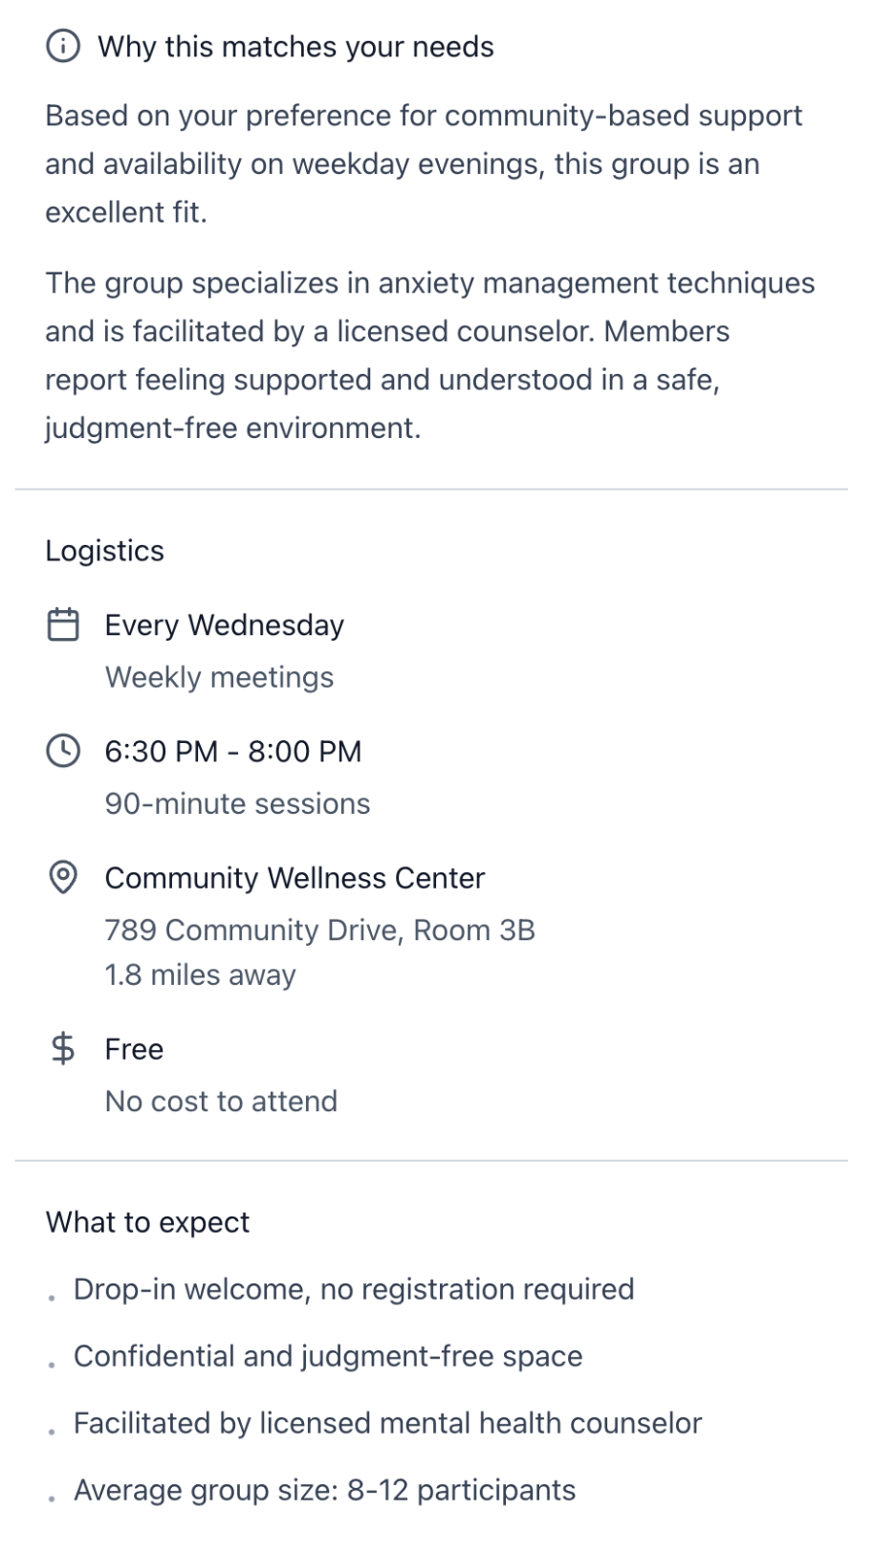
Resource Detail: Anxiety Support Group - West Side
User Stories Addressed:
As Marcus, I want to see why each resource was recommended for me so I can trust that the suggestions are personalized. (Child Story #5)
As Marcus, I want to view the logistics for each resource so I can decide if it's realistic for me. (Child Story #6)
Key UI Elements:
"Why this matches your needs" section with personalized rationale, Logistics section (schedule, time, location with distance, cost), "What to expect" section (drop-in, confidential, facilitator credentials, group size), clear I'm Interested and Not for me actions
Design Decision:
Match rationale appears first because trust is the primary barrier. Logistics are scannable with icons. "What to expect" reduces anxiety about attending. The "Not for me" link (Child Story #8) provides dismissal without requiring explanation unless tapped.

Usability Testing

Part 1: Clinician Flow Testing

Subject Scenario
You are Dr. Sarah Chen, a psychiatrist at Valley Community Mental Health Center in Roanoke, VA. You manage a panel of 90 patients, mostly Medicaid and Medicare. You have 15 minutes between appointments and want to connect your patient to community resources without adding significant time to your workflow.
Your patient is Marcus Thompson, a 34-year-old with moderate depression (MDD) who recently stabilized on sertraline. He works remotely, lives alone, and has low energy, especially in the evenings. He used to enjoy hiking. You want to connect him to resources that fit his situation.

Pre-Session Checklist
# | Item | Notes
1 | Intro | Welcome the tester. Explain this is a test of the product, not of them.  Read the Dr. Chen scenario aloud. Confirm they understand the context.  Open the Figma prototype to the Patient Selection screen (C1).
2 | Testing | Walk through each test item. Ask prompts; do not explain how to complete tasks.  Record points of confusion, hesitation, and verbal feedback.  Note time to complete each task if relevant.
3 | Debrief | What was easy? What was confusing?  Would this fit into a 15-minute appointment window?  What would make you more or less likely to use this?

Clinician Test Items
# | User Story | Prompts | Output / OEC
C1 | As Dr. Chen, I want to select my patient's diagnosis so recommendations are clinically appropriate. | Moderator:  "Find Marcus Thompson and select his diagnosis."  "How would you indicate he has Major Depressive Disorder?" | Can subject locate patient and navigate to diagnosis screen?  Time to complete selection (<60 sec target)
C2 | As Dr. Chen, I want to set treatment phase and resource tiers so I can control recommendation intensity. | Moderator:  "Marcus just stabilized on medication. Set the appropriate treatment phase."  "Which types of resources would you approve for him?" | Does subject select "Early Recovery"?  Can subject articulate difference between tiers?
C3 | As Dr. Chen, I want to review the Care Plan before sharing so I can verify recommendations make sense. | Moderator:  "Review the recommendations. Would you approve this Care Plan for Marcus?"  "Tell me about one resource that seems like a good fit and why." | Does subject review all recommendations?  Can subject explain match rationale?
C4 | As Dr. Chen, I want to send the assessment link to my patient so they can complete preferences on their own time. | Moderator:  "Send this Care Plan to Marcus."  "What do you expect will happen next?" | Can subject locate and complete send action?  Does subject understand patient will receive link?

Part 2: Patient Flow Testing

Subject Scenario
You are Marcus Thompson, 34, and you have moderate depression. You recently stabilized on medication after six months of adjustments. You work remotely as a customer service rep and live alone in an apartment. You moved to Roanoke two years ago for a relationship that ended, and your social network never recovered.
Dr. Chen told you to "get more involved" and sent you a link to something called Tether. You're skeptical but willing to try. Your energy is low, especially in the evenings. You used to enjoy hiking but don't have anyone to go with anymore.

Pre-Session Checklist
# | Item | Notes
1 | Intro | Welcome the tester. Explain this is a test of the product, not of them.  Read the Marcus scenario aloud. Confirm they understand the context.  Open the Figma prototype to the Welcome screen (P1).
2 | Testing | Walk through each test item. Ask prompts; do not explain how to complete tasks.  Record points of confusion, hesitation, and verbal feedback.  Pay attention to emotional reactions (trust, skepticism, relief).
3 | Debrief | Did the recommendations feel personalized or generic?  Would you actually attend any of these resources? Why or why not?  What would make you trust the recommendations more?

Patient Test Items
# | User Story | Prompts | Output / OEC
P1 | As Marcus, I want to understand what Tether is and why my doctor sent it so I can decide whether to complete the assessment. | Moderator:  "You just received this link from Dr. Chen. What is this?"  "Would you continue? Why or why not?" | Can subject explain the purpose of Tether?  Does subject proceed past welcome screen?
P2 | As Marcus, I want to answer questions about my preferences so I can receive recommendations that fit my routine. | Moderator:  "Complete the assessment questions."  "Do you understand why this question is being asked?" | Does subject complete assessment without confusion?  Can subject articulate connection between question and matching?
P3 | As Marcus, I want to see why each resource was recommended so I can trust the suggestions are personalized. | Moderator:  "Look at your recommendations. Pick one that interests you."  "Why do you think this was recommended for you?" | Can subject find and articulate match rationale?  Does subject express trust or skepticism?
P4 | As Marcus, I want to view logistics so I can decide if a resource is realistic for me. | Moderator:  "Could you attend this resource? Tell me the schedule, location, and cost."  "What would you do next if you wanted to attend?" | Can subject locate all logistics (time, location, cost)?  Does subject understand next steps?
P5 | As Marcus, I want to indicate interest or dismiss recommendations so I can get help with next steps. | Moderator:  "Mark the resources you're interested in."  "One of these doesn't fit. Show me how you'd indicate that." | Can subject find interest/dismiss actions?  Does subject understand feedback improves future matches?

Success Metrics
The following metrics define success for each flow:

Clinician Flow
Task completion rate: >90% complete all tasks without assistance
Time to complete full flow: <3 minutes
Comprehension: >80% can explain resource tier differences
Satisfaction: >80% say this would fit their workflow

Patient Flow
Task completion rate: >90% complete all tasks without assistance
Time to complete assessment: <5 minutes
Trust: >70% say recommendations feel personalized (not generic)
Intent: >50% say they would actually attend at least one resource
Comprehension: >80% can articulate why a resource was recommended

